**Unit -II**

# MACHINE LEARNING Notes - 201CS6T01

Supervised Learning(Regression/Classification):Basic Methods: Distance based Methods, Nearest Neighbours, Decision Trees, Naive Bayes, Linear Models: Linear Regression, Logistic Regression, Generalized Linear Models, Support Vector Machines, Binary Classification: Multiclass/Structured outputs, MNIST, Ranking.

## TOPIC-1: Basic Methods- Distance based Methods, Nearest Neighbours, Decision Trees, Naive Bayes:

**Distance Based Methods:**Distance-based algorithms are machine learning algorithms that classify queries by computing distances between these queries .

# K-Nearest Neighbor(KNN) Algorithm for Machine Learning

* K-Nearest Neighbour is one of the simplest Machine Learning algorithms based on Supervised Learning technique.
* K-NN algorithm assumes the similarity between the new case/data and available cases and put the new case into the category that is most similar to the available categories.
* K-NN algorithm stores all the available data and classifies a new data point based on the similarity. This means when new data appears then it can be easily classified into a well suite category by using K- NN algorithm.
* K-NN algorithm can be used for Regression as well as for Classification but mostly it is used for the Classification problems.
* K-NN is a **non-parametric algorithm**, which means it does not make any assumption on underlying data.
* It is also called a **lazy learner algorithm** because it does not learn from the training set immediately instead it stores the dataset and at the time of classification, it performs an action on the dataset.
* KNN algorithm at the training phase just stores the dataset and when it gets new data, then it classifies that data into a category that is much similar to the new data.

## Why do we need a KNN algorithm?

Suppose there are two categories, i.e., Category A and Category B, and we have a new data point x1, so this data point will lie in which of these categories. To solve this type of problem, we need a K-NN algorithm. With the help of K-NN, we can easily identify the category or class of a particular dataset. Consider the below diagram:

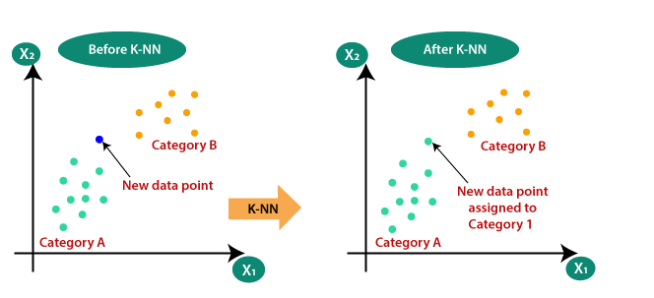

## Advantages of KNN Algorithm:

* It is simple to implement.
* It is robust to the noisy training data
* It can be more effective if the training data is large.

## Disadvantages of KNN Algorithm:

* Always needs to determine the value of K which may be complex some time.
* The computation cost is high because of calculating the distance between the data points for all the training samples.

# Decision Tree Classification Algorithm

* Decision Tree is a **Supervised learning technique**that can be used for both classification and Regression problems, but mostly it is preferred for solving Classification problems. It is a tree-structured classifier, where**internal nodes represent the features of a dataset, branches represent the decision rules** and **each leaf node represents the outcome.**
* In a Decision tree, there are two nodes, which are the **Decision Node** and**Leaf Node.** Decision nodes are used to make any decision and have multiple branches, whereas Leaf nodes are the output of those decisions and do not contain any further branches.
* The decisions or the test are performed on the basis of features of the given dataset.
* **It is a graphical representation for getting all the possible solutions to a problem/decision based on given conditions.**
* It is called a decision tree because, similar to a tree, it starts with the root node, which expands on further branches and constructs a tree-like structure.
* In order to build a tree, we use the **CART algorithm,** which stands for **Classification and Regression Tree algorithm.**
* A decision tree simply asks a question, and based on the answer (Yes/No), it further split the tree into subtrees.
* Below diagram explains the general structure of a decision tree:

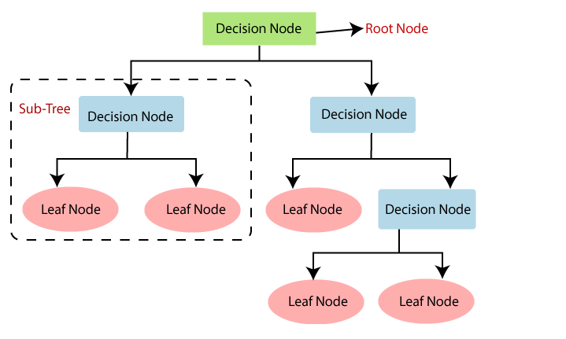

## Decision Tree Terminologies

* **Root Node:** Root node is from where the decision tree starts. It represents the entire dataset, which further gets divided into two or more homogeneous sets.
* **Leaf Node:** Leaf nodes are the final output node, and the tree cannot be segregated further after getting a leaf node.
* **Splitting:** Splitting is the process of dividing the decision node/root node into sub-nodes according to the given conditions.
* **Branch/Sub Tree:** A tree formed by splitting the tree.
* **Pruning:** Pruning is the process of removing the unwanted branches from the tree.
* **Parent/Child node:** The root node of the tree is called the parent node, and other nodes are called the child nodes.

## How does the decision tree algorithm work?:

* **Step-1:** Begin the tree with the root node, says S, which contains the complete dataset.
* **Step-2:** Find the best attribute in the dataset using **Attribute Selection Measure (ASM).**
* **Step-3:** Divide the S into subsets that contains possible values for the best attributes.
* **Step-4:** Generate the decision tree node, which contains the best attribute.
* **Step-5:** Recursively make new decision trees using the subsets of the dataset created in step -3. Continue this process until a stage is reached where you cannot further classify the nodes and called the final node as a leaf node.

**Example:** Suppose there is a candidate who has a job offer and wants to decide whether he should accept the offer or Not. So, to solve this problem, the decision tree starts with the root node (Salary attribute by ASM). The root node splits further into the next decision node (distance from the office) and one leaf node based on the corresponding labels. The next decision node further gets split into one decision node (Cab facility) and one leaf node. Finally, the decision node splits into two leaf nodes (Accepted offers and Declined offer). Consider the below diagram:

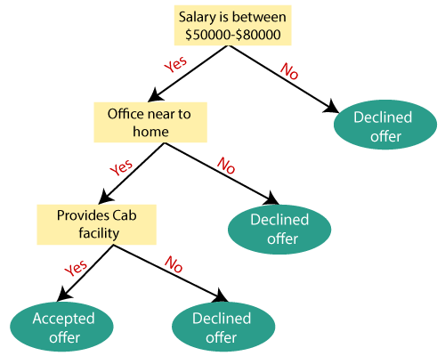

## Advantages of the Decision Tree

* It is simple to understand as it follows the same process which a human follow while making any decision in real-life.
* It can be very useful for solving decision-related problems.
* It helps to think about all the possible outcomes for a problem.
* There is less requirement of data cleaning compared to other algorithms.

## Disadvantages of the Decision Tree

* The decision tree contains lots of layers, which makes it complex.
* It may have an overfitting issue, which can be resolved using the **Random Forest algorithm.**
* For more class labels, the computational complexity of the decision tree may increase.

# Naïve Bayes Classifier Algorithm

* Naïve Bayes algorithm is a supervised learning algorithm, which is based on **Bayes theorem** and used for solving classification problems.
* It is mainly used in text classification that includes a high-dimensional training dataset.
* Naïve Bayes Classifier is one of the simple and most effective Classification algorithms which helps in building the fast machine learning models that can make quick predictions.
* **It is a probabilistic classifier, which means it predicts on the basis of the probability of an object**.
* Some popular examples of Naïve Bayes Algorithm are **spam filtration, Sentimental analysis, and classifying articles**.

## Why is it called Naive Bayes?

The Naive Bayes algorithm is comprised of two words Naïve and Bayes, Which can be described as:

* **Naive**: It is called Naïve because it assumes that the occurrence of a certain feature is independent of the occurrence of other features. Such as if the fruit is identified on the bases of color, shape, and taste, then red, spherical, and sweet fruit is recognized as an apple. Hence each feature individually contributes to identify that it is an apple without depending on each other.
* **Bayes**: It is called Bayes because it depends on the principle of [**Bayes' Theorem**](https://www.javatpoint.com/bayes-theorem-in-artifical-intelligence).

## Bayes' Theorem:

* Bayes' theorem is also known as **Bayes' Rule** or **Bayes' law**, which is used to determine the probability of a hypothesis with prior knowledge. It depends on the conditional probability.
* The formula for Bayes' theorem is given as:

Naïve Bayes Classifier Algorithm

**Where,**

**P(A|B) is Posterior probability**: Probability of hypothesis A on the observed event B.

**P(B|A) is Likelihood probability**: Probability of the evidence given that the probability of a hypothesis is true.

**P(A) is Prior Probability**: Probability of hypothesis before observing the evidence.

**P(B) is Marginal Probability**: Probability of Evidence.

### Advantages of Naïve Bayes Classifier:

* Naïve Bayes is one of the fast and easy ML algorithms to predict a class of datasets.
* It can be used for Binary as well as Multi-class Classifications.
* It performs well in Multi-class predictions as compared to the other Algorithms.
* It is the most popular choice for **text classification problems**.

### Disadvantages of Naïve Bayes Classifier:

* Naive Bayes assumes that all features are independent or unrelated, so it cannot learn the relationship between features.

### Applications of Naïve Bayes Classifier:

* It is used for **Credit Scoring**.
* It is used in **medical data classification**.
* It can be used in **real-time predictions** because Naïve Bayes Classifier is an eager learner.
* It is used in Text classification such as **Spam filtering** and **Sentiment analysis**.

## TOPIC-2: Linear Models:Linear Regresion ,Logistic Regression,Generalized Linear Models,Support Vector Machines

### 1. Linear Regression

Linear regression is one of the most popular and simple machine learning algorithms that is used for predictive analysis. Here, **predictive analysis** defines prediction of something, and linear regression makes predictions for continuous numbers such as **salary, age, etc.**

It shows the linear relationship between the dependent and independent variables, and shows how the dependent variable(y) changes according to the independent variable (x).

It tries to best fit a line between the dependent and independent variables, and this best fit line is knowns as the regression line.

The linear regression model provides a sloped straight line representing the relationship between the variables. Consider the below image:

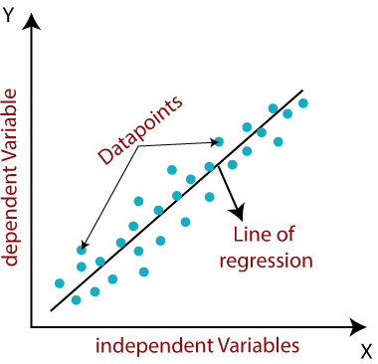

The equation for the regression line is:

y= a0+ a*x+ b

Here, y= dependent variable

x= independent variable

a0= Intercept of line.

Linear regression is further divided into two types:

* **Simple Linear Regression:** In simple linear regression, a single independent variable is used to predict the value of the dependent variable.
* **Multiple Linear Regression:** In multiple linear regression, more than one independent variables are used to predict the value of the dependent variable.

## Linear Regression Line

A linear line showing the relationship between the dependent and independent variables is called a **regression line**. A regression line can show two types of relationship:

**Positive Linear Relationship:**

* If the dependent variable increases on the Y-axis and independent variable increases on X-axis, then such a relationship is termed as a Positive linear relationship.

**Negative Linear Relationship:**

* If the dependent variable decreases on the Y-axis and independent variable increases on the X-axis, then such a relationship is called a negative linear relationship.

# Logistic Regression in Machine Learning

* Logistic regression is one of the most popular Machine Learning algorithms, which comes under the Supervised Learning technique. It is used for predicting the categorical dependent variable using a given set of independent variables.
* Logistic regression predicts the output of a categorical dependent variable. Therefore the outcome must be a categorical or discrete value. It can be either Yes or No, 0 or 1, true or False, etc. but instead of giving the exact value as 0 and 1, **it gives the probabilistic values which lie between 0 and 1**.
* Logistic Regression is much similar to the Linear Regression except that how they are used. Linear Regression is used for solving Regression problems, whereas **Logistic regression is used for solving the classification problems**.
* In Logistic regression, instead of fitting a regression line, we fit an "S" shaped logistic function, which predicts two maximum values (0 or 1).
* The curve from the logistic function indicates the likelihood of something such as whether the cells are cancerous or not, a mouse is obese or not based on its weight, etc.
* Logistic Regression is a significant machine learning algorithm because it has the ability to provide probabilities and classify new data using continuous and discrete datasets.
* Logistic Regression can be used to classify the observations using different types of data and can easily determine the most effective variables used for the classification. The below image is showing the logistic function:

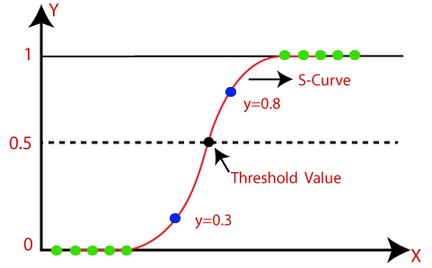

## Assumptions for Logistic Regression:

* The dependent variable must be categorical in nature.
* The independent variable should not have multi-collinearity.

## Logistic Regression Equation:

The Logistic regression equation can be obtained from the Linear Regression equation. The mathematical steps to get Logistic Regression equations are given below:

* We know the equation of the straight line can be written as:

Logistic Regression in Machine Learning

* In Logistic Regression y can be between 0 and 1 only, so for this let's divide the above equation by (1-y):

Logistic Regression in Machine Learning

* But we need range between -[infinity] to +[infinity], then take logarithm of the equation it will become:

Logistic Regression in Machine Learning

The above equation is the final equation for Logistic Regression.

## Type of Logistic Regression:

On the basis of the categories, Logistic Regression can be classified into three types:

* **Binomial:** In binomial Logistic regression, there can be only two possible types of the dependent variables, such as 0 or 1, Pass or Fail, etc.
* **Multinomial:** In multinomial Logistic regression, there can be 3 or more possible unordered types of the dependent variable, such as "cat", "dogs", or "sheep"
* **Ordinal:** In ordinal Logistic regression, there can be 3 or more possible ordered types of dependent variables, such as "low", "Medium", or "High".

# Support Vector Machine Algorithm

Support Vector Machine or SVM is one of the most popular Supervised Learning algorithms, which is used for Classification as well as Regression problems. However, primarily, it is used for Classification problems in Machine Learning.

The goal of the SVM algorithm is to create the best line or decision boundary that can segregate n-dimensional space into classes so that we can easily put the new data point in the correct category in the future. This best decision boundary is called a hyperplane.

SVM chooses the extreme points/vectors that help in creating the hyperplane. These extreme cases are called as support vectors, and hence algorithm is termed as Support Vector Machine. Consider the below diagram in which there are two different categories that are classified using a decision boundary or hyperplane:

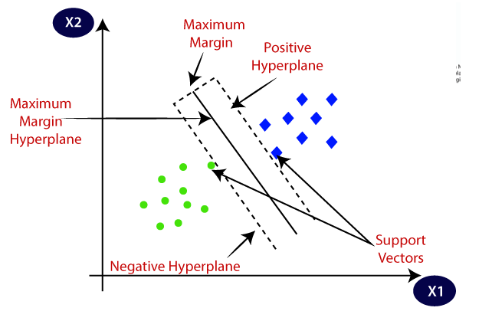

SVM algorithm can be used for **Face detection, image classification, text categorization,** etc.

## Types of SVM

**SVM can be of two types:**

* **Linear SVM:** Linear SVM is used for linearly separable data, which means if a dataset can be classified into two classes by using a single straight line, then such data is termed as linearly separable data, and classifier is used called as Linear SVM classifier.
* **Non-linear SVM:** Non-Linear SVM is used for non-linearly separated data, which means if a dataset cannot be classified by using a straight line, then such data is termed as non-linear data and classifier used is called as Non-linear SVM classifier.

**Advantages and Disadvantages**

It uses a subset of training points in the decision function which makes it memory efficient and is highly effective in high dimensional spaces. The only disadvantage with the support vector machine is that the algorithm does not directly provide probability estimates.

.

## TOPIC-3 Binary Classification:

Binary Classification is a process or task of classification, in which a given data is being classified into two classes.  It’s basically a kind of prediction about which of two groups the thing belongs to.

Let us suppose, two emails are sent to you, one is sent by an insurance company that keeps sending their ads, and the other is from your bank regarding your credit card bill. The email service provider will classify the two emails, the first one will be sent to the spam folder and the second one will be kept in the primary one.

This process is known as binary classification, as there are two discrete classes, one is spam and the other is primary. So, this is a problem of binary classification.

### ****Term Related to binary classification****

#### ****PRECISION****

#### Precision in binary classification (Yes/No) refers to a model's ability to correctly interpret positive observations. In other words, how often does a positive value forecast turn out to be correct? We may manipulate this metric by only returning positive for the single observation in which we have the most confidence.

#### ****RECALL****

#### The recall is also known as sensitivity.  In binary classification (Yes/No) recall is used to measure how “sensitive” the classifier is to detecting positive cases. To put it another way, how many real findings did we “catch” in our sample? We may manipulate this metric by classifying both results as positive.

#### ****F1 SCORE****

#### The F1 score can be thought of as a weighted average of precision and recall, with the best value being 1 and the worst being 0. Precision and recall also make an equal contribution to the F1 ranking.

**Multi-class Classification:**

An input can belong to exactly one of the K classes

Training Data : Each input feature vector xi is associated with a class label yi ∈ {1, . . . ,K}

Prediction : Given a new input, predict the class label

Eg. Object Classification, Document Classification, Optical Character Recognition, Context sensitive spelling correction etc.

**Structured Output Prediction:**

**We can successfully (?) do multiclass classification**

Assign topics to documents

Names to object images

Sentiments to reviews

**How do we take this knowledge of ML to predict,**

Assign topics to documents that come from a label hierarchy

Parse objects in scene and find relations between them. eg. OCR

Find the adjectives, verbs, nouns in reviews to possible perform aspect based sentiments

**Example:**

sequence Labeling : Parts-of-Speech Tagging

Input : A sequence of objects.

Output : A sequence of labels of the same length as input

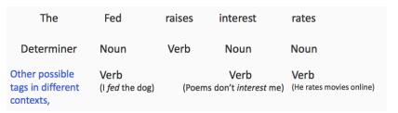

Inference : For sequence size = n and T possible tags, output search

space is O(T^n)

**MNIST:**

The **MNIST database** (*Modified*[*National Institute of Standards and Technology*](https://en.wikipedia.org/wiki/National_Institute_of_Standards_and_Technology)*database*[[1]](https://en.wikipedia.org/wiki/MNIST_database#cite_note-1)) is a large [database](https://en.wikipedia.org/wiki/Database) of handwritten digits that is commonly used for [training](https://en.wikipedia.org/wiki/Training_set) various [image processing](https://en.wikipedia.org/wiki/Image_processing) systems.[[2]](https://en.wikipedia.org/wiki/MNIST_database#cite_note-2)[[3]](https://en.wikipedia.org/wiki/MNIST_database#cite_note-3) The database is also widely used for training and testing in the field of [machine learning](https://en.wikipedia.org/wiki/Machine_learning)

The [MNIST database](http://yann.lecun.com/exdb/mnist/) (Modified National Institute of Standards and Technology database) of handwritten digits consists of a training set of 60,000 examples, and a test set of 10,000 examples. It is a subset of a larger set available from NIST. Additionally, the black and white images from NIST were size-normalized and centered to fit into a 28x28 pixel bounding box and anti-aliased, which introduced grayscale levels.

This database is well liked for training and testing in the field of machine learning and image processing. It is a remixed subset of the original NIST datasets. One half of the 60,000 training images consist of images from NIST's testing dataset and the other half from Nist's training set. The 10,000 images from the testing set are similarly assembled.

The MNIST dataset is used by researchers to test and compare their research results with others. The lowest error rates in literature are as low as 0.21 percent.1

**Ranking:**

Ranking is a type of supervised machine learning (ML) that uses labeled datasets to train its data and models to classify future data to predict outcomes. Quite simply, the goal of a ranking model is to sort data in an optimal and relevant order.

Ranking was first largely deployed within search engines. People search for a topic, while the ranking algorithm reorders search results based on the [PageRank](https://en.wikipedia.org/wiki/PageRank), and the search engine is able to display the most relevant results to its customers.

Until recently, most ranking models, and ML as whole, were limited in their scope of use, as most companies didn’t have enough data to power these algorithms. Better methods for data collection and more intuitive ML tools have made it possible for nearly anyone to deploy a successful ranking model within their business.

Ranking models are made up of 2 main factors: queries and documents. Queries are any input value, such as a question on Google or an interaction on an e-commerce site. Documents are the output value or results of the query. Given the query, and the associated documents, a function, given a list of parameters to rank on, will score the documents to be sorted in order of relevancy.

The machine learning algorithm [learning to rank](https://en.wikipedia.org/wiki/Learning_to_rank) takes the scores from this model, and uses them to predict future outcomes on a new and unseen list of documen